Presentation layer

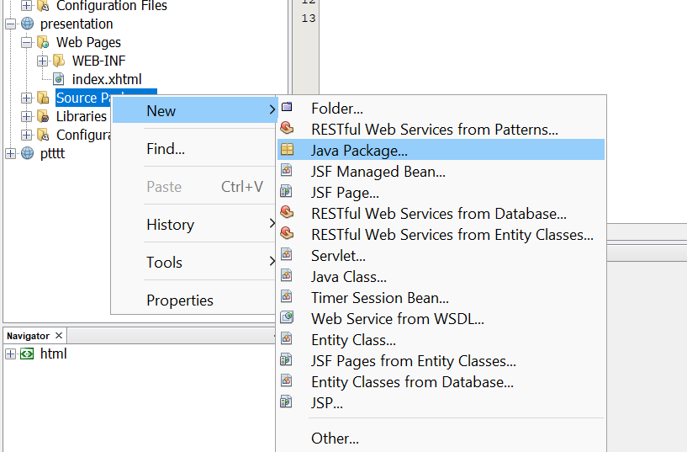

TWO TIMES: BEANS AND SERVICES

REFRACTOR THE CONTENTS OF ruas.basic.com to SERVICES

IN BEANS DO THE FOLLOWING:

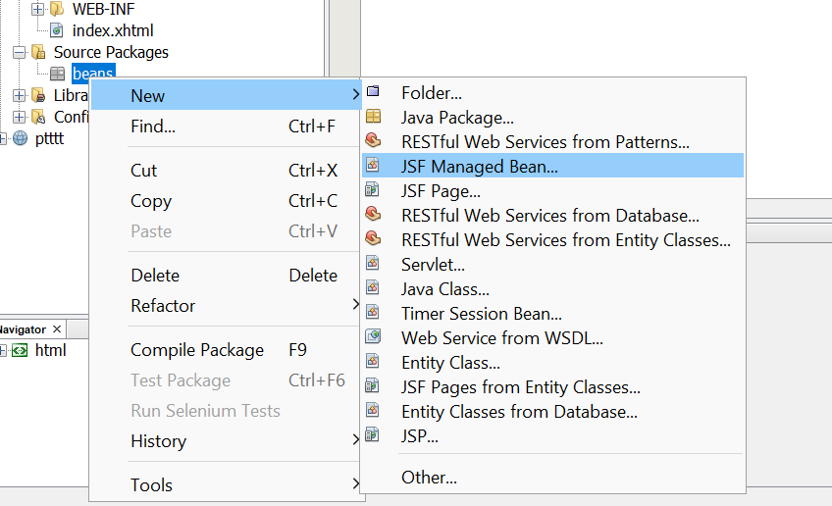

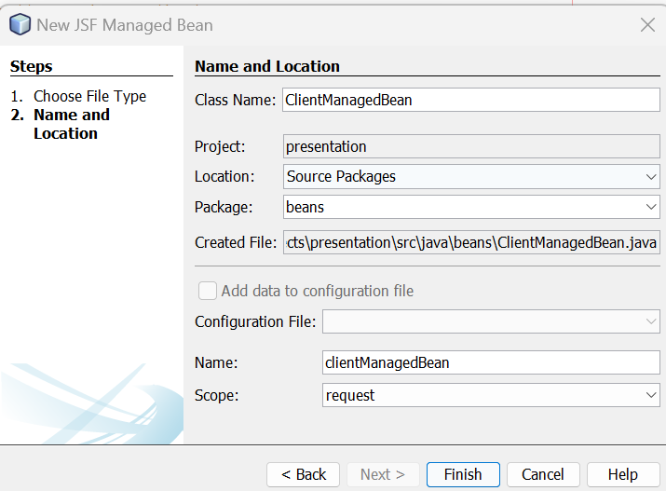

MAKE SURE THE SCOPE IS REQUEST.

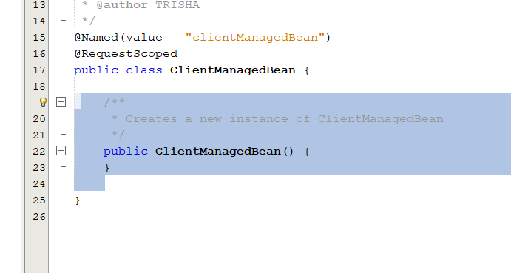

DELETE THE SELECTED PART

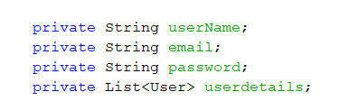

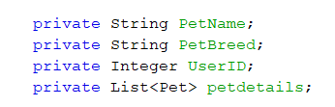

PASTE THE ATTRIBUTES THERE

INSERT CODE OPTION CHOOSE GENERATE REST:

GET USER FAÇADE AND DO THE SAME FOR PET FaCADE

Step 69

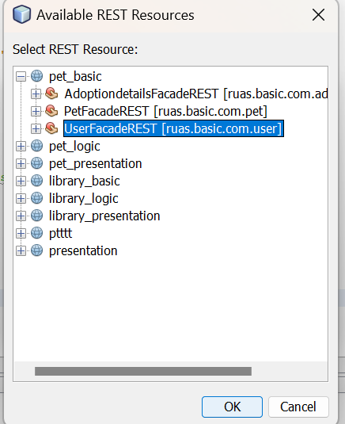

AGAIN INSERT CODE : GETTER AND SETTER :SELECT ALL

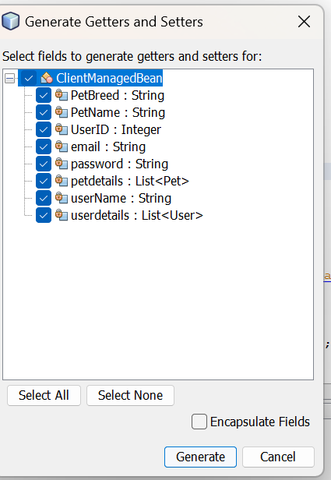

PASTE THE CODE FOR GETTING AND ADDING USER

IT WILL BE THERE IN THE clientManagedBean of the presentation layer…..DO THE SAME FOE GETTING AND ADDING PET:

IM PASTING THE CODE HERE IN CASE YOU CANT FIND IT :

**FOR USER: HERE MAKE SURE THAT THE JerseyClient name matches the one you got when you inserted the code in the step 69**

**public String getUsersList(){**

**//get list of users**

**UserBusinessesResource_JerseyClient BpClient = new UserBusinessesResource_JerseyClient();**

**GenericType<List<User>> gType = new GenericType<List<User>>() {};**

**List<User> persons = (List<User>) BpClient.GetUsers(gType);**

**List<User> listofusers = new ArrayList<User>();**

**for (User p : persons) {**

**listofusers.add(p);**

**}**

**userdetails = listofusers;**

**return "List of Users";**

**}**

**public String addUser() {**

**//Registration for New Users**

**UserBusinessesResource_JerseyClient BpClient1 = new UserBusinessesResource_JerseyClient();**

**User b = new User();**

**b.setEmail(email);**

**b.setUsername(userName);**

**b.setPassword(password);**

**BpClient1.CreateUser(b);**

**return "New User Added";**

**}**

**FOR PET: HERE MAKE SURE THAT THE JerseyClient name matches the one you got when you inserted the code in the step 69**

**public String addPet(){**

**PetBusinessesResource_JerseyClient BpClient1 = new PetBusinessesResource_JerseyClient();**

**Pet p = new Pet();**

**p.setName(PetName);**

**p.setBreed(PetBreed);**

**User b1 = new User();**

**b1.setUserID(UserID);**

**p.setUserID(b1);**

**BpClient1.CreatePet(p);**

**return "New Pet Added";**

**}**

**public String getPetDetails(){**

**PetBusinessesResource_JerseyClient UserClient = new PetBusinessesResource_JerseyClient();**

**GenericType<List<Pet>> gType = new GenericType<List<Pet>>() {};**

**List<Pet> Pets = (List<Pet>) UserClient.GetPets(gType);**

**List<Pet> listofpets = new ArrayList<Pet>();**

**for (Pet p : Pets) {**

**listofpets.add(p);**

**}**

**petdetails = listofpets;**

**return "List of Pets";**

**}**

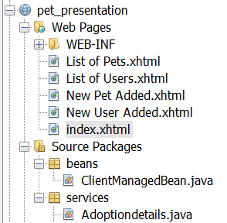**HERE RIGHT CLICK ON WEB PAGES AND CREATE 4 NEW JFS PAGES INITIALLY ONLY INDEX WILL BE THERE.**

**MAKE SURE THAT THE ________ManagedBean name in same in all the html files**

**INDEX.XHTML FILE**

<!DOCTYPE html>

<html xmlns="http://www.w3.org/1999/xhtml"

xmlns:h="http://xmlns.jcp.org/jsf/html"

xmlns:f="http://xmlns.jcp.org/jsf/core">

<head>

<title>Registration Page</title>

</head>

<body>

<h:form>

<h:panelGrid columns="2" cellpadding="5">

<h:outputLabel for="username" value="Username:" />

<h:inputText id="username" value="#{clientManagedBean.userName}" />

<h:outputLabel for="email" value="Email:" />

<h:inputText id="email" value="#{clientManagedBean.email}" />

<h:outputLabel for="password" value="Password:" />

<h:inputSecret id="password" value="#{clientManagedBean.password}" />

</h:panelGrid>

<h:commandButton value="Register" action="#{clientManagedBean.addUser()}" />

</h:form>

<h:form>

<h:commandButton value="List of Users" action="#{clientManagedBean.getUsersList()}" />

</h:form>

<h:form>

<h:panelGrid columns="2" cellpadding="5">

<h:outputLabel for="petname" value="Pet Name:" />

<h:inputText id="petname" value="#{clientManagedBean.petName}" />

<h:outputLabel for="breed" value="Breed:" />

<h:inputText id="breed" value="#{clientManagedBean.petBreed}" />

<h:outputLabel for="userid" value="User ID:" />

<h:inputText id="userid" value="#{clientManagedBean.userID}" />

</h:panelGrid>

<h:commandButton value="Register" action="#{clientManagedBean.addPet()}" />

</h:form>

<h:form>

<h:commandButton value="List of Pets" action="#{clientManagedBean.getPetDetails()}" />

</h:form>

</body>

</html>

**FOR NEW USER ADDED:**

<?xml version='1.0' encoding='UTF-8' ?>

<!DOCTYPE html PUBLIC "-//W3C//DTD XHTML 1.0 Transitional//EN" "http://www.w3.org/TR/xhtml1/DTD/xhtml1-transitional.dtd">

<html xmlns="http://www.w3.org/1999/xhtml"

xmlns:h="http://xmlns.jcp.org/jsf/html">

<h:head>

<title>Facelet Title</title>

</h:head>

<h:body>

<h:form>

<h:commandButton value="List of Users" action="#{clientManagedBean.getUsersList()}" />

</h:form>

</h:body>

</html>

**NEW PET ADDED:**

<?xml version='1.0' encoding='UTF-8' ?>

<!DOCTYPE html PUBLIC "-//W3C//DTD XHTML 1.0 Transitional//EN" "http://www.w3.org/TR/xhtml1/DTD/xhtml1-transitional.dtd">

<html xmlns="http://www.w3.org/1999/xhtml"

xmlns:h="http://xmlns.jcp.org/jsf/html">

<h:head>

<title>Facelet Title</title>

</h:head>

<h:body>

<h:form>

<h:commandButton value="List of pets" action="#{clientManagedBean.getPetDetails()}" />

</h:form>

</h:body>

</html>

**LIST OF PETS:**

<!DOCTYPE html>

<html xmlns="http://www.w3.org/1999/xhtml"

xmlns:h="http://xmlns.jcp.org/jsf/html"

xmlns:f="http://xmlns.jcp.org/jsf/core">

<head>

<title>Pet List</title>

</head>

<body>

<h2>Pet List</h2>

<h:form>

<h:dataTable value="#{clientManagedBean.petdetails}" var="pet" border="1">

<h:column>

<f:facet name="header">Pet Name</f:facet>

#{pet.name}

</h:column>

<h:column>

<f:facet name="header">Breed</f:facet>

#{pet.breed}

</h:column>

<h:column>

<f:facet name="header">User ID</f:facet>

#{pet.userID.userID}

</h:column>

</h:dataTable>

</h:form>

</body>

</html>

**LIST OF USERS:**

<!DOCTYPE html>

<html xmlns="http://www.w3.org/1999/xhtml"

xmlns:h="http://xmlns.jcp.org/jsf/html"

xmlns:f="http://xmlns.jcp.org/jsf/core">

<head>

<title>User List</title>

</head>

<body>

<h2>User List</h2>

<h:form>

<h:dataTable value="#{clientManagedBean.userdetails}" var="user" border="1">

<h:column>

<f:facet name="header">Username</f:facet>

#{user.username}

</h:column>

<h:column>

<f:facet name="header">Email</f:facet>

#{user.email}

</h:column>

<h:column>

<f:facet name="header">Password</f:facet>

#{user.password}

</h:column>

</h:dataTable>

</h:form>

</body>

</html>

THEN NORMAL JUST CLEAN AND BUILD…..DEPLOY…..RUN….THE REHISTRATION FORM WILL OPEN